HOME APPLIANCES CONTROL SYSTEM BASED ON THE ANDROID

AIM:
The main aim of this project is to develop a smart home automation system, which uses Bluetooth technology that will control the operation of these appliances with respect to the command sent by the Android mobile.
PURPOSE:
The purpose of this project is to provide to control different appliances automatically and to gain the remote access of different units using the Bluetooth technology.
SMART HOME:

MICRO CONTROLLER
(AT89S52)

POWER SUPPLY

BLUETOOTH
RELAY1
LAMP1
RELAY2
LAMP2
DRIVER CIRCUIT
DC FAN
DRIVER CIRCUIT
DC MOTOR
LCD
MAX232

REMOTE UNIT:
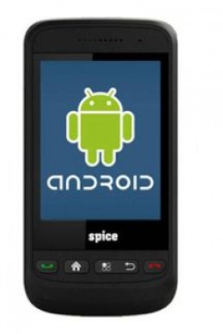
DESCRIPTION:
Smart home provides a method to control the system with advanced android mobile using Bluetooth. It is designed to give the user the ability to manage all equipment that is capable of being automated from a single controlling source. Viewing all of the automation equipment in a consistent and uniform way solves the first and primary problem with home automation.
Smart Home Technology is a collective term for information and communication-technology in homes, where the components are communicating through a Bluetooth. The technology may be used for monitoring, switching on and off the components, according to the programmed criteria. The smart home section is kept in the home. We can connect various appliances to this system. The user can control the appliances using his/her android mobile using Bluetooth technology. The information to turn ON or OFF the appliances is sent from android mobile and this is received by the Bluetooth module in the system. According to that particular appliance is turned ON or OFF.

BLUETOOTH TECHNOLOGY:
Bluetooth was selected as our way of communicating PDA/Mobile with a central system. The reason Bluetooth was selected over Bluetooth for various reasons. First of all, Bluetooth security is less complex and more stable than that of Wi-Fi. Bluetooth manages a security measure of only permitting certain selected devices to interact with them; Wi-Fi in the other hand establishes a WEP key that has been known to be cracked. Another reason that Bluetooth was selected over Wi-Fi is that Bluetooth has a shorter range of signal emission than Wi-Fi. This is a pro because the shorter the range the less the amount intruders that will try to infiltrate your home system.
Android:
Android is a software stack for mobile devices that includes an operating system, middleware and key applications. The Android SDK provides the tools and APIs necessary to begin developing applications on the Android platform using the Java programming language.

HARDWARE:
- Android mobile
- Micro Controller (AT89S52).

SOFTWARE:
- Android SDK
- Eclipse SDK
- Keil Micro-vision 3

RESULT:
The use of modern technology is adding to a safe and comfortable living environment for everybody. For the disabled person, the benefits are even greater. Smart home technology has proved to contribute to increased independence and safety for lots of end-users, their families and careers.

